Introduction:
The skeletal system is a primary system of the human body that involves many components with multiple functions. The objective of this Jab is to identify to first identify the pattern of motion of the joints in the skeletal system by comparing them to mechanical joints; In the second part of the lab, you will measure the range of motion of a body joint using a measurement tool and compare your results.

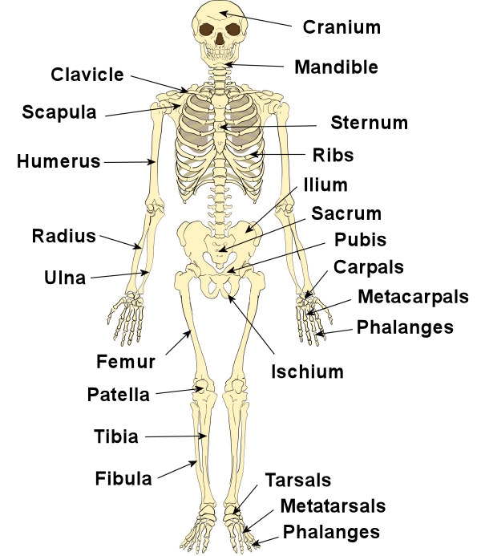

Figure 1: The primary bones in the skeletal system.

- Based on what you have learned in engineering mechanics, anatomy and physiology and biomechanics, pick 5 large joints of the body and name the appropriate mechanical joint (Hinge, Ball & Socket, slider, etc) that can represent the anatomical function of that joint.
Hip joint – Ball and socket joint
Elbow – Hinge joint
Between radius and carpal bones of the wrist – condyloid joint
Between C1 and C2 Verterbrae – pivot joint
Between trapezium carpal bone and 1st metacarpal bone – saddle joint.

Part 2: Joint Kinematics

Lower extremity joint have crucial roles in movement of lower body. Figure 2 shows the body of a subject in two positions, upright standing and half squat. In this exercise we want to measure the angle of the knee and the ankle joints with body in two postures as shown and see the difference.

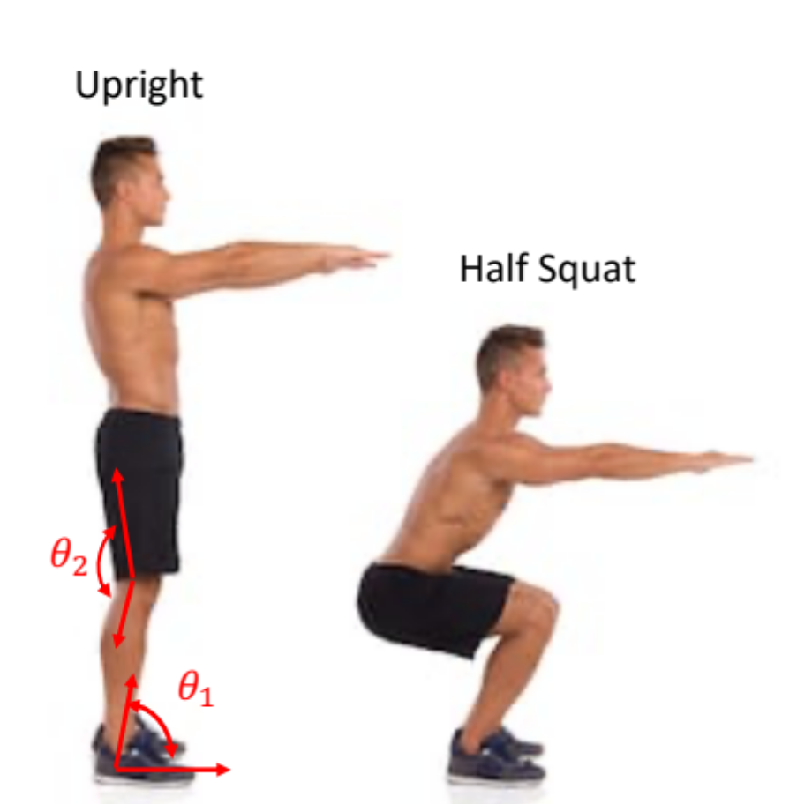

Figure 2: Subject showing upright and squat postures.

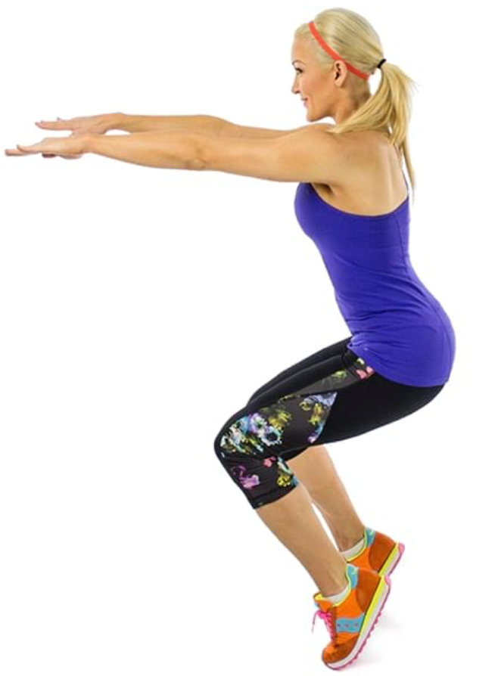

Figure 3: Subject in on-toe half squat posture .

Procedure:
- Perform the squat motion as shown in figures 1 & 2 and measure the angles of the knee and ankle joint using goniometer in these three postures: upright, half-squat foot flat, on-toe square (figure 3).
- Perform three measurements for each posture and type the angles in tables 1 and 2.

Exercise:

- Perform lower limb exercises as shown in figure 4. Do each exercise two times and hold body in shown posture for at least 5 seconds.
- Repeat steps 1-2 and record the angles and add them to tables 3 & 4.

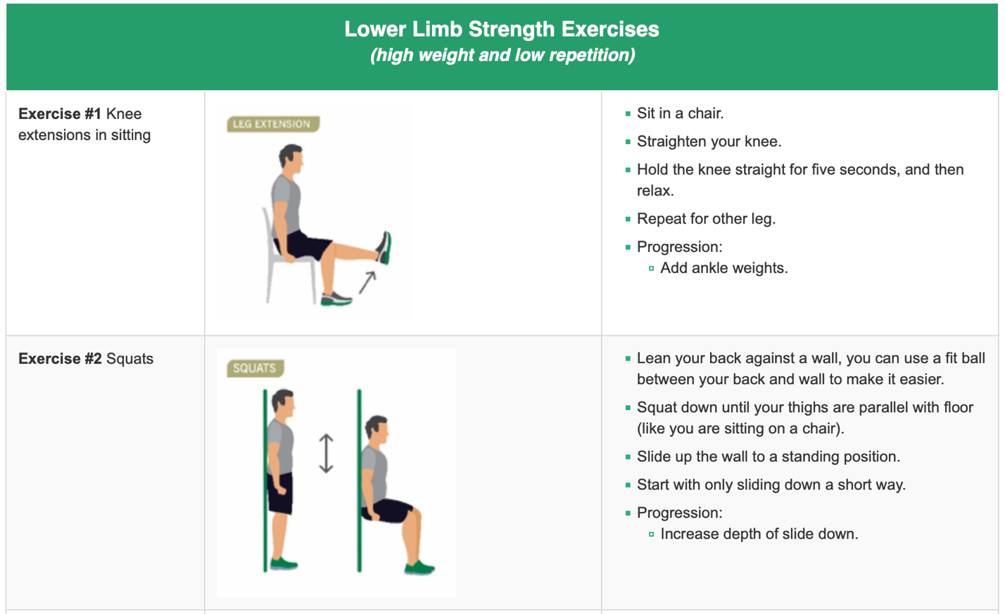
Figure 4: Lower limb exercise.

Tables:
Table 1 (Knee angleBeforeexercise):

Position-Angle: | Left knee angle (deg) |  |  | Right knee angle (deg)
Position-Angle: | Upright | Half Squat (foot flat) | Half Squat (on toe) | Upright | Half Squat (foot flat) | Half Squat (on toe)
Trial 1 | 3 | 76 | 80 | 3 | 76 | 80
Trial 2 | 3 | 76 | 79 | 3 | 76 | 80
Trial 3 | 3 | 76 | 81 | 3 | 76 | 80
Average | 3 | 76 | 80 | 3 | 76 | 80

Table 2 (Ankle angle Beforeexercise):

Position-Angle: | Left ankle angle (deg) |  |  | Right ankle angle (deg)
Position-Angle: | Upright | Half Squat (foot flat) | Half Squat (on toe) | Upright | Half Squat (foot flat) | Half Squat (on toe)
Trial 1 | 84 | 106 | 110 | 84 | 106 | 110
Trial 2 | 84 | 107 | 111 | 84 | 107 | 111
Trial 3 | 84 | 105 | 109 | 84 | 105 | 109
Average | 84 | 105 | 110 | 84 | 105 | 110

Table 3 (Knee angle Afterexercise):

Position-Angle: | Left knee angle (deg) |  |  | Right knee angle (deg)
Position-Angle: | Upright | Half Squat (foot flat) | Half Squat (on toe) | Upright | Half Squat (foot flat) | Half Squat (on toe)
Trial 1 | 3 | 85 | 86 | 3 | 85 | 86
Trial 2 | 3 | 84 | 90 | 3 | 84 | 90
Trial 3 | 3 | 86 | 88 | 3 | 86 | 88
Average | 3 | 85 | 88 | 3 | 85 | 88

Table 4 (Ankle angle afterexercise):

Position-Angle: | Left ankle angle (deg) |  |  | Right ankle angle (deg)
Position-Angle: | Upright | Half Squat (foot flat) | Half Squat (on toe) | Upright | Half Squat (foot flat) | Half Squat (on toe)
Trial 1 | 90 | 111 | 114 | 90 | 111 | 114
Trial 2 | 90 | 112 | 114 | 90 | 110 | 114
Trial 3 | 90 | 110 | 114 | 90 | 112 | 114
Average | 90 | 111 | 114 | 90 | 111 | 114

Knee and Ankle motions measurement experiment:

- How does the angle of your left knee and ankle joints compares against the angle of the right side joints in half squat flat foot posture?
The angle of the left knee before squatting is 76, which is the same as the angle of the same joints on the right side, while that of the ankle is 106 for both sides. After the exercise, the angles for both knees (right and left have an average of 85, while the knees average at 111.
- How does the angle of your left knee and ankle joints compares against the angle of the right side joints in on-toe half squat posture?
The angle of the left knee and ankle before squatting has the same values as the angles of the same joints on the right side. The angles also remain similar for both sides in both joints after the exercise. The body is symmetrical before and after the exercise in relation to the angles of the joints while on an on-toe posture.
- How does the angle of the knee joint (left or right) in squat (flat foot) differ from the angle of the joint in on-toe squat posture?
Both knees record an angle of 76 before the exercise on a flat foot posture, while the same angle on an on-toe posture is 86. The same joint have records of 88 when on an on-toe posture, while a flat foot posture records 85 after the exercise. The flat foot posture has lower records that the former.
- How does the angle of the ankle joint (left or right) in squat (flat foot) differs from the angle of the joint in on-toe squat?
The flat foot posture records lower readings for both ankles from the on-toe posture before and after the exercise. The former posture records an average of 111 after and 105 before the squat, while the latter posture records averages of 110 and 114 before and after the exercise respectively.
- In which posture (flat foot versus on-toe) you feel more muscle forces being applied to your bones? Explain from biomechanics perspective.
The on-toe posture has more muscles force applied to the bones while compared to the flat foot posture. The former posture exerts all the body weight on the balls of the feet, while the latter distributes the weight throughout from the heels to the balls of the feet.
- In which posture (flat foot versus on-toe) it is more difficult to maintain body’s stability, why?
The on-toe posture presents ore difficulty in maintaining body stability in comparison with the flat foot posture. The former offers low surface area in contact with the ground which supports the body as opposed to the latter, with high stability associated with a bigger surface area.
- Does exercise have any impact on the angle of the knee and the ankle joints in squat (flat foot) and on-toe squat postures? explain from biomechanics perspective.
The angle of the knee and ankle joints determines the stretch of various muscles involved in the exercise. They are, therefore, influential in the stability and posture of the body all the way from the point of support on the ground.

